FOR IMMEDIATE RELEASE: April 22, 2009
Contact: Gentle Thunder - (530) 925-4495/ gthunder@jps.net

GRAMMY® NOMINEE GENTLE THUNDER’S MUSIC FLOWS LIKE H₂0

Mt. Shasta, CA – This year’s work in progress performances for H₂O Manifesto, conceived, directed written and choreographed by Krista Miller, co-written by Jason Gigliotti and featuring the music GRAMMY® nominated artist Gentle Thunder with additional composition by David Schanaker have already impacted audiences by taking the water bottling issue and the state of our water on the planet to a new level of community awareness and dialogue this past October. Debuting on May 8th in north Siskiyou County, this multi-discipline production flows along to the haunting recorded musical score by multi-instrumentalist Gentle Thunder and is supplemented featuring live music by Gentle Thunder on drum set and Native American flutes, Terry Lawhon on guitar, and Ariah Firefly on keyboards and vocals. This will be a one night only show to be experienced, even if you saw it before, with a great cast of new and returning talented actors, dancers, and musicians. May 8, 2009 at the Yreka Community Theater at 7:30 pm. Tickets $15 Adults/ $8 Senior/Students at: Village Books, Nature’s Kitchen and Yreka Chamber Commerce and charge online at: www.siskiyouartscouncil.org/h2o More info: (530) 859-1309.

Gentle Thunder’s previous solo recording, Opening the Gate, nominated Best Native American Album in the 2007 New Age Reporter Lifestyle Awards, is richly woven with several pieces inspired by and created for the musical score for Mt. Shasta City Dance Theater’s H₂O Manifesto. “For me, H₂O Manifesto is a powerful performance art, theater, dance piece that speaks to the sacredness of water, and the powerful issues surrounding us locally and globally regarding bottling issues as we steward and care for our pristine waters. I’m grateful for this opportunity to align my artistry with the vision of such a talented artist/dancer/choreographer like Krista Miller and this diverse cast,” said GT in an email. “It is extremely satisfying to see what Miller has done with all of my music, including pieces from my previous albums. To see the music come to life ‘as water’ and the dancers dance to one of my classic pieces like Spirit Fire is deeply moving for me as an artist. There are some great new additions to the cast, like professional dancer Jessica Coleman, who have really added to the production. We are performing it in a real theater for the first time and so the audience will be able to see the whole stage revealing the real depth and beauty of Miller’s choreography. I look forward to joining this stellar cast on stage from behind my drum set in Yreka for what I envision to be a sold out one night only performance at the Community Theater,” added Gentle Thunder.

Gentle Thunder, often and aptly nicknamed Rolling Thunder, was recently in Memphis, TN performing and celebrating the release of a new CD by her former powerhouse vocalist Susan Marshall who fronted the last rock-n-roll band that GT recorded and performed with. It was 16 years ago GT left the rock-n-roll drumming business and moved to Mt. Shasta. Memphis is where GT first played and became captivated by the hammer dulcimer and her Native American Cree ancestry. While exploring her Cree ancestry on her Mother's side, a door opened to her spiritual path, as she "remembered" her interconnectedness to ALL life and began to consciously walk the beauty way. “It was a powerful trip this past week to bring to Memphis what I have cultivated musically on Native flute and hammer dulcimer all these years celebrating the growth and success that has come from following my heart and branching out as a solo artist. It was amazing,” declared Gentle Thunder. 2009 has already been busy on the road, highlighted by a number of special guest appearances on Native American flute with former member of Jefferson Starship, multi-platinum, GRAMMY® nominated guitarist Craig Chaquico and his band. Since February, Gentle Thunder has performed in Austin, TX; Santa Cruz, CA; San Francisco Bay Area; Memphis, TN followed by Ashland, OR May 1st and Yreka, CA for H₂O Manifesto. Her production company has expanded its focus to offer mentoring and to teach lessons as her touring schedule allows. “I intend to be home in Mt. Shasta more this year and available for those who would like to expand their creative outlet (not just musical) via lessons, workshops and school presentations. It is my delight to be sharing wisdom from my 30 year music career with the intent to inspire students as a part of Hannah Johnson’s senior project during the resource and arts professional forum as part of the student program on May 8th”, said Gentle Thunder. Details please see article on H20 Manifesto and Hannah Johnson in this week’s issue. Contact Gentle Thunder: 530.925.4495/ www.GentleThunder.com

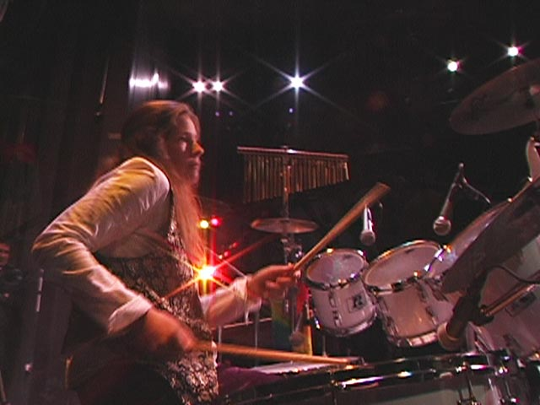
Photo by John Cumming attached: GTOnDrums1.jpg (Gentle Thunder behind the drum set)

